ADVANCED MANUFACTURING & MECHATRONICS  Pre-Apprenticeship Program · CraftED  Week 4 · Lesson 7 · Schematic Interpretation and Logic Ladders  Apply & Reflect — Student Response Form | 

Student Information

Full Name: | Date Submitted:
Week / Lesson: | Cohort / Instructor:

Section 2: Apply — Skill Demonstration

Part A — HVAC Schematic Annotation: The “System Logic” Challenge

Study the HVAC Wiring Diagram (Figure 1) on the following page. This diagram shows how 240V components (Compressor, Condenser Fan, Evaporator Fan, Heater) are controlled by a 24V thermostat circuit through a transformer.
Answer all six annotation questions below. Reference the diagram directly for each answer. Precision and specificity earn full marks — vague answers do not.

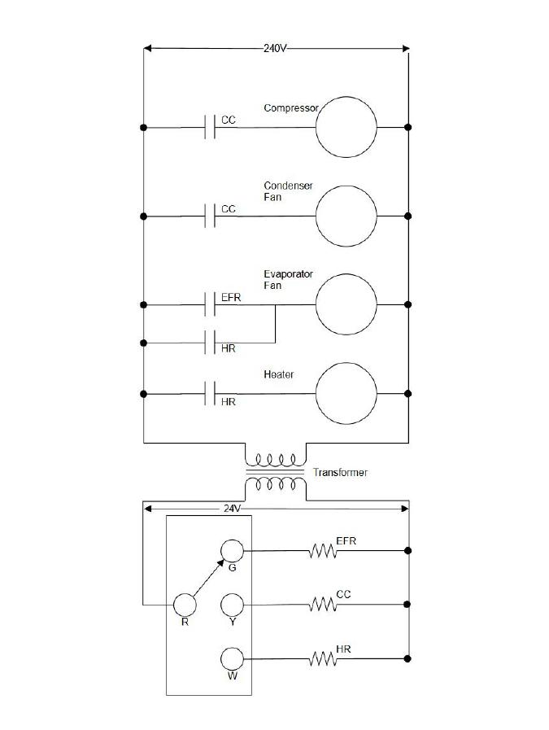
Figure 1: HVAC System Wiring Diagram — 240V Power Circuit (top) and 24V Control Circuit (bottom). Use this diagram to complete all questions in Part A.
 | Annotation Question | Your Answer
☐ | Q1 — Identify the Voltage Bridge: Circle the Transformer on your printed diagram. Describe its purpose in protecting the “brain” of the system. Why is stepping down from 240V to 24V important for the control circuit? | The transformer steps down voltage because… Without it, the control circuit would…
☐ | Q2 — Trace the Compressor Logic: Locate the Compressor and its CC contact in the 240V section. Is this contact Normally Open (NO) or Normally Closed (NC)? What is the state of the compressor when the CC relay coil is de-energized? | The CC contact is: ☐ NO ☐ NC — When the CC coil is de-energized, the compressor is: ☐ Running ☐ Off — Reasoning:
☐ | Q3 — Cross-System Mapping: Find the CC Relay Coil in the 24V control section. When the thermostat moves to Y (Cooling), describe the complete sequence of events that causes the high-voltage Compressor to turn on. Trace every step. | Step 1: Thermostat moves to Y → Step 2: … → Step 3: … → Step 4: Compressor energizes because…
☐ | Q4 — Sequential Logic (OR Logic): The Evaporator Fan has two contacts in parallel: EFR and HR. Explain why this “OR” wiring is necessary for the system to function correctly during both heating and cooling cycles. | During cooling, the Evaporator Fan runs because… During heating, it runs because… If only Series (AND) wiring were used instead, the problem would be…
☐ | Q5 — Identifying the Common Rail: Highlight the two vertical lines (left and right) of the 240V section. Why are these called “Rails”? What do they represent in terms of electrical potential (Hot/Line vs. Neutral/Ground)? | The left rail represents… The right rail represents… Every component in this circuit is connected between the rails because…
☐ | Q6 — Component Interdependence: Both the Condenser Fan and the Compressor have contacts labeled CC. Explain precisely why these two different motors turn on at exactly the same time. What would happen if you removed the CC contact from the Condenser Fan rung? | Both motors share the CC contact because… If the CC contact were removed from the Condenser Fan rung, the result would be… This matters for system safety because…
☐ | Q7 — Challenge: State-Change Prediction — The Transformer Fails: If the transformer fails and outputs 0V on the secondary side, which 240V loads stop immediately? Which continue running? Explain the logic for each answer. | Loads that stop: … because… | Loads that continue: … because… | Key insight: The 24V circuit controls… but the 240V rail…
☐ | Print or download Figure 1 (HVAC Schematic above) and annotate your copy. Circle the transformer, highlight the rails, and label each component with its relay coil or contact type (NO/NC). Attach your annotated diagram to this submission.

Schematic Summary (3–5 sentences) *
In your own words, describe what this HVAC schematic is “doing” as a system. What is the relationship between the 24V control section and the 240V power section? Why is this architecture used in industrial machines?…

Part B — Design: The “Dual-Hand Safety Press” Ladder Logic Diagram

You are a Logic Architect. Design a safety circuit for a heavy industrial press that requires both hands to start. On a clean sheet of paper, draw a professional ladder logic rung and attach it to this submission.
Design Requirements: (1) E-STOP: one Master Stop button (NC) that kills all power instantly · (2) Dual-Hand Start: two separate NO Start buttons wired in Series so the motor only runs if BOTH are held simultaneously · (3) Latch: motor stays on via a Latching Contact until Stop is pressed · (4) Green Pilot Light energized only when the motor is running
Label all symbols using industry shorthand: E-STOP · ST1 · ST2 · MTR · LT1 · CR1 (Control Relay for the latch). Sketch must show at least two rungs: Rung 1 (Start/Stop/Latch logic) and Rung 2 (Pilot Light).
Reference the three-rung PLC example from the lesson. Your Dual-Hand design follows the same latching pattern but adds the safety-critical Series requirement for ST1 and ST2.

Sketch Checklist — confirm before submitting your sketch:
☐ E-STOP (NC) is in series at the start of the rung (breaking the circuit kills all power)
☐ ST1 (NO) and ST2 (NO) are wired in Series (both must be held to close the rung)
☐ CR1 Latch contact (NO) is wired in Parallel with ST1 and ST2 (holds the circuit closed after release)
☐ MTR coil (Output) is on the right end of Rung 1
☐ Rung 2: MTR contact (NO) in series with LT1 (Green Light) — light is on only when motor runs
☐ All symbols labeled with correct industry shorthand (E-STOP, ST1, ST2, MTR, LT1, CR1)
Attach your hand-drawn or digitally drawn ladder logic sketch here or as a separate page in your PDF submission.

Design Logic Explanation (6–8 sentences) *
Explain your Dual-Hand Press design in words. Why must ST1 and ST2 be in Series rather than Parallel? What happens if the E-STOP is pressed while the motor is running? How does the Latch contact prevent the motor from stopping when the operator releases the Start buttons?…

Part C — Connecting Schematics to Real Manufacturing Systems

The HVAC schematic and the Dual-Hand Press both use the same fundamental architecture: a low-voltage control brain switching a high-voltage power muscle. This is the same design used in PLC-controlled manufacturing machines.
Answer both questions below, connecting what you built this week to your manufacturing career pathway.

In a CNC machine, robot cell, or conveyor system at your career pathway facility — describe one real situation where a technician would use schematic reading skills to isolate a fault. Be specific about the machine, the symptom, and how they would use the diagram. *
If you were the Ladder Logic designer for a robot cell that requires a light curtain (safety sensor) to be clear before a robot arm can move, describe how you would wire the light curtain into the ladder. Would you use NO or NC? Where would it go in the rung? Why? *

Schematic Literacy Career Reflection (5–7 sentences): Explain why a technician who cannot read a schematic is “troubleshooting blind.” How does the ability to trace relay logic across voltage levels make you more valuable on a manufacturing shop floor? Connect your answer to your specific career pathway. *
A technician who cannot read a schematic must… whereas a technician who can read one can… In my pathway as a [role], this skill matters most when…

Section 3: Evaluation Rubric

Criterion | Exceeds (4) | Meets (3) | Approaching (2) | Needs Support (1)
Technical Accuracy | Correctly identifies transformer roles, NC/NO states, and component interdependence in all Part A questions. | Correctly identifies symbols with minor logic errors in one or two questions. | Misidentifies one or more major components or logic relationships. | Fails to identify basic symbol types or circuit structure.
Logic Design | Dual-Hand (Series) and Latch logic work perfectly in the sketch; all symbols correctly labeled with industry shorthand. | Circuit works but is missing the safety E-STOP, Latch, or Pilot Light element. | Sketch does not create a continuous power path or is missing two or more required elements. | No sketch provided or logic is non-functional.
State-Change Prediction | Clearly explains transformer failure consequences and E-STOP logic; connects relay coil states to physical machine outcomes. | Understands power vs. control architecture but lacks technical detail in state-change explanations. | General comments without linking logic to physical machine states. | Minimal or no understanding of system states or control logic.
Professional Presentation | Sketch is labeled with industry shorthand, clearly organized, and portfolio-ready. Annotations are specific and technically precise. | Shorthand is present but inconsistent; annotations are generally correct. | Missing labels or technical terminology; sketch difficult to follow. | Incomplete or unprofessional presentation.

Section 4: Upload & Documentation Protocol

Combine all files (application evidence) into one PDF.
Name your file using this format: Lastname_Week4.7.pdf
Upload to the assignment portal.
Keep a copy in your Career Portfolio Folder (Google Drive).

Pre-Submission Checklist  ☐ All 6 annotation questions answered with specific references to the diagram  ☐ Q7 Transformer Failure Challenge completed  ☐ Annotated copy of HVAC schematic attached  ☐ Dual-Hand Safety Press ladder logic sketch attached  ☐ Sketch checklist completed (E-STOP, ST1, ST2, Latch, MTR, Pilot Light)  ☐ Design logic explanation written (6–8 sentences)  ☐ Manufacturing career connection and light curtain design questions answered  ☐ Schematic literacy career reflection written (5–7 sentences)  ☐ Name, date, and week number included  File name: Lastname_Week4.7.pdf | Instructor Use Only  Technical Accuracy  ☐ 1 ☐ 2 ☐ 3 ☐ 4  Logic Design  ☐ 1 ☐ 2 ☐ 3 ☐ 4  State-Change Prediction  ☐ 1 ☐ 2 ☐ 3 ☐ 4  Professional Presentation  ☐ 1 ☐ 2 ☐ 3 ☐ 4  TOTAL: ___ / 16

